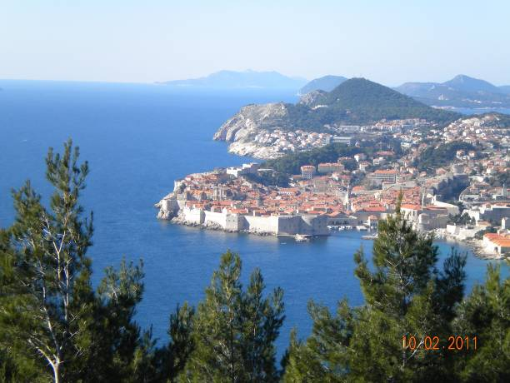
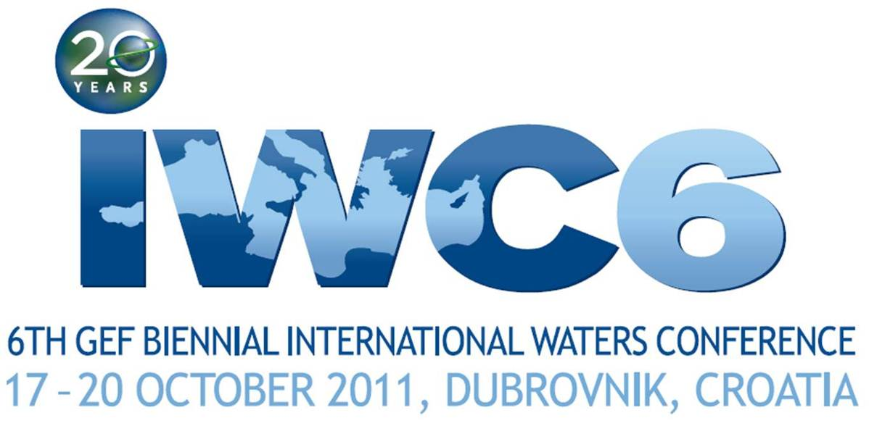
RAISING THE BAR:
20 YEARS OF GEF
TRANSBOUNDARY WATER RESULTS

Valamar Lacroma Dubrovnik Hotel
Dubrovnik, Croatia
17-20 October 2011
www.iwlearn.net/iwc2011
Second Announcement

What is the GEF and its International Waters Focal Area?
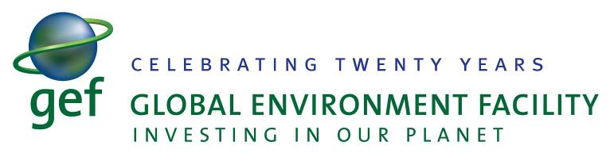
The Global Environment Facility (GEF) – www.thegef.org, unites 182 member governments - in partnership with international institutions, nongovernmental organizations, and the private sector — to address global environmental issues. An independent financial organization, the GEF provides grants to developing countries and countries with economies in transition for projects related to biodiversity, climate change, international waters, land degradation, the ozone layer, and persistent organic pollutants. These projects benefit the global environment, linking local, national, and global environmental challenges and promoting sustainable livelihoods

The GEF International Waters (IW) focal area targets transboundary water systems, such as shared river basins, lakes, groundwater and large marine ecosystems. The IW portfolio comprises to date 170 projects and consists of some US$1.2 billion of GEF grants invested in 149 different countries globally. This investment has leveraged approximately US$ 5 billion in co-financing. Since the inception of the GEF in 1991, the IW portfolio has delivered substantive results and replicable experiences to be scaled-up and mainstreamed globally.

What is the IWC6, its objectives and theme?
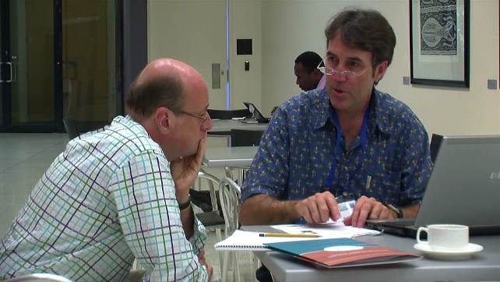
The Sixth GEF Biennial International Waters Conference, as in prior IW Conferences, will be a signature active training and experience-sharing event for the GEF IW focal area. The general objective of the GEF Biennial International Waters Conference is to facilitate portfolio-wide experience sharing. They also exist to solicit advice from the IW project portfolio on burning issues and assist in building participant capacity in key management and technical areas.
Participants of the IWC5 in Australia

This year the Conference will coincide with the 20th anniversary of the GEF’s establishment. Thus the Conference will be organized under the slogan Raising the Bar: 20 Years of GEF Transboundary Water Results, and will focus on water management issues and results since 1991. There will be sub-themes focusing on environmental finance (featuring for the first-time a roundtable on corporate and social responsibility with private sector companies), as well as considerations of the institutional & sectoral transformation.

Who are its participants?

The IWC6 will convene at least 300 participants, including GEF IW project managers, representatives of beneficiary countries, non-governmental organizations, transboundary management institutions, UN agencies and the private sector. Collectively they will represent about 70 active GEF IW projects, 80 countries and the various GEF Agencies. The conference is by invitation only, with participants nominated by the GEF Agencies implementing IW projects.

What is the agenda-at-a-glance?

Manager Workshops 15-16 October |  | Day 1 - 17 October
TARGETED WORKSHOPS FOR IW MANAGERS & AGENCIES |  | PARTICIPANT WELCOME AND CONSIDERING IW RESULTS
0930-1730  Consultation on the Draft GEF IW Project Manager’s Manual  Location: Dubrovnik University, Villa Elisa  Targeted workshops for GEF IW project managers and agency staff. The day will start with a look at the proposed new focal area course and manual developed by the GEF IW:LEARN project. The rest of the day will be spent with the Legal and Institutional Frameworks Project, which has developed a set of new governance tools for GEF IW projects. | 0930-1730  Development of TDA’s and SAP’s : A Revision to the Methodology and Course  Location: Dubrovnik University, Villa Elisa  Targeted workshops for GEF IW project managers and government representatives on the development of Transboundary Diagnostic Analyses and Strategic Action Programs.  Please note that conference registration will start in the afternoon. | 0900-0915  IWC6 Expectations Video
0915-1000
Keynote Welcome Addresses
Božidar Pankretić, Croatian Minister of Regional Development, Forestry and Water Management (TBC)

Maria Luisa Silva Mejia, Coordinator, UNEP MEditerranean Action Plan

Dubrovnik Municipality/Neretva-Dubrovnik County (TBC)

1000-1030
Welcome from the GEF: Focusing on Results
Alfred Duda, Senior Advisor International Waters, GEF

1030-1045
IWC6 Objectives and Expectations
IW:LEARN
1045-1130
Refreshments, Networking & Bilateral Time
Location: Innovation Marketplace
1130-1300
Adriatic/Mediterranean Region Achievements & Initiatives

Results from the project portfolio in this region and plans for the future, featuring the Mediterranean Strategic Partnership, Dinaric Karst Aquifer, Neretva & Trebišnjica rivers, Croatian Coastal Cities, Skadar-Shkodra Lake and Croatian Agricultural Pollution Control projects. .
1300-1430
Lunch & Networking
Location: Lunchroom/Innovation Marketplace
1430-1600
Small Table Dialogues on Applying Project Results
Location: Plenary Room

Small working groups discuss results of the IW portfolio and carrying them forward, with professional facilitation.
1600-1700
Refreshments, Networking & Bilateral Time
Location: Innovation Marketplace
 | 1500-1800  Innovation Marketplace Setup  Location: | 1700-1800  Interactive Event  Location: Plenary Room  An exercise to acquaint participants with the GEF IW tracking tool and its application to Results-Based Management in the IW Portfolio
 | 1830-2030  Welcome Reception  Location: TBD  Remarks by the Croatian Government and Cultural Event. | 1800-2000  Film Festival and Innovation Marketplace Review  Location: TBD
AGENDA-AT-A-GLANCE
Day 2 - 18 October | Day 3 - 19 October |  |  | Day 4 - 20 October
GEF IW ECOSYSTEM  PROJECT SITE VISITS | GEF5, SUSTAINING GEF IW RESULTS THROUGH COMMISSIONS AND PRIVATE SECTOR ENGAGEMENT |  |  | THE PATH FORWARD
0700-????  Technical Site Visits to Multiple GEF IW Projects: Ridge to Reef, Lakes, Rivers, Groundwater and Marine Ecosystems  Location: Various  1. Mljet Island  2. Ston & Neretva River Delta (travel thru Bosnia & Herzegovina)  3. Trebišnjica River & Dinaric Karst (travel to Bosnia & Herzegovina)  4. Skadar-Shkodra Lake (travel to Montenegro)  Technical site visits will include marine, surface freshwater and groundwater watershed management options for participants, and these will showcase integrated water and other natural resource management issues (such as mariculture, wastewater treatment, transboundary hydroelectric production); as well as local innovations and best practices aimed at addressing those issues and consequences. For the first time ever, all site visits will be to GEF IW project sites and in most cases will showcase transboundary management. | 0900-0915  Reflection Video & Feedback |  |  | 0900-0915  Reflection Video & Feedback
 | 0915-1045  Programming GEF5  Location: Plenary Room |  |  | 0915-1045  Participant-led Workshops  Location: Various  Participants will prepare workshops prior to the IWC to offer in during this session (or on an ad hoc basis).
 | 1045-1130  Refreshments, Networking & Bilateral Time  Location: Innovation Marketplace |  |  | 1045-1130  Refreshments, Networking & Bilateral Time  Location: Innovation Marketplace
 | 1130-1300  Discussion of Small Table Dialogues Outcomes: Applying Project Results  Location: TBD |  |  | 1130-1300  Participant-led Workshops  Location: Various
 | 1300-1430  Lunch & Networking  Location: Lunchroom |  |  | 1300-1430  Lunch & Networking  Location: Lunchroom
 | 1430-1600  Workshops and Roundtables  Location: TBD |  |  | 1430-1630  Closing Plenary: Looking Back, Looking Ahead  The closing plenary will feature reflections on the IWC and the way forward for GEF IW, first from Project Managers, then the GEF IW Task Force, and finally an awards ceremony.
 | GEF Science and Technical Panel Session | Corporate Social Responsibility Roundtable
 | 1600-1630  Refreshments, Networking & Bilateral Time  Location: Innovation Marketplace |  |  | 1630-1800  Innovation Marketplace Teardown & Caribbean Farewell Drink  Location: Innovation Marketplace
1630-1800
Workshops and Roundtables continued
Location: TBD
 | GEF Science and Technical Panel Session (cont…) | Transboundary Commission Roundtable | Corporate Social Responsibility Roundtable Breakout
2000-2400
20th Anniversary Reception
Location: Revelin Fortress

What sessions will be conducted and when will the 20 Years of GEF IW be celebrated?
The IWC6 will feature extensive opportunities for focused learning on scientific and technical innovations, interactive training for IW project managers and country representatives, an innovation marketplace (exhibit area) on project results, interaction with the GEF Secretariat, GEF agencies and several partner institutions working on International Waters projects. The Conference will feature training sessions on key management and technical areas, such as the preparation of transboundary diagnostic analyses and strategic action programmes and project management. For the first time a corporate and social responsibility roundtable with private sector companies, as well as a transboundary commission roundtable will be organized. Finally, there will be participant-driven training workshops.
The conference will be dedicated to the celebration of the 20th Anniversary of GEF IW focal area. This culminates in a reception on the 19 October. Senior management and representatives of sponsors and the private sector will also be welcomed to join.

What technical site visit options are available?
On the 18 October there will be a unique and unprecedented option of undertaking technical site visits to not just one, but five GEF IW projects in a transboundary context around Dubrovnik and, in some cases, to the neighboring countries of Bosnia and Herzegovina and Montenegro. Participants will be able to get acquainted with the progress achieved by these projects, to discuss and share their experiences in the context of actual projects. The technical site visits are a critical and mandatory part of the training programme. All of these will showcase integrated water and other natural resource management; the consequences of climatic variability and change, as well as local innovations and best practices dealing, including public-private partnerships. The participants will hear presentations from, and be guided by, leading regional scientists and natural resource managers working in the various ecosystems visited. As all but one of the site visits will involve border crossings, arrangements will need to be made well in advance of embarkation. Complete descriptions of all the technical site visits during the IWC6, including important logistical notes associated with each trip, are available at: http://iwlearn.net/abt_iwlearn/events/iwc6/iwc6-site-visit.

Lake Basin Integrated Ecosystem Management: The Skadar-Shkoder Lake

This technical site visit will give participants the chance to visit and study the most advanced active GEF IW project in the region, the Skadar (Montenegrin) - Shkoder (Albanian) Lake Basin project. This transboundary project provides many lessons of interest, particularly for freshwater basin projects, on various issues, including inter alia:
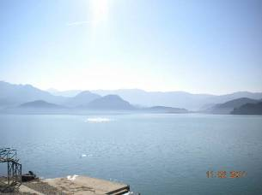
The Skadar/Shkodra Lake (photo V. Mamaev)
- Institutional cooperation and establishment of joint transboundary commissions
- Sustainable approaches to economic development
- Tourism and fisheries
- Investments to stimulate pollution reduction activities
- Village-level wastewater treatment and buffer vegetation restoration
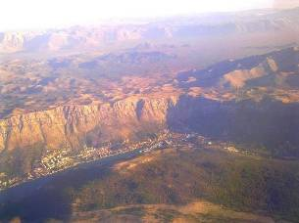
The Ombla Spring in Croatia with Bosnia & Herzegovina in the background (photo Dinaric Karst project)

The Lost River and Transboundary Interactions: The Trebišnjica River Basin
Did you know that more than 25 percent of the world’s population either lives on or obtains its water from karst aquifers? Karst is a special type of geologic environment that is formed by dissolution soluble rocks, such as limestone and dolomite. The Trebisnjica river basin is world renown as an exemplary karst field, featuring among others sinking and reappearance of the river itself, at various locations and in various countries. Nothing exemplifies the hydrologic linkages between countries in the Western Balkans more than the Trebišnjica River basin system. Participants will visit sites of the Dinarick Karst Aquifer Project as well as the Neretva & Trebisnjica GEF projects to look at issues like hydropower generation, wastewater management and surface & sub-surface interactions.

Mariculture & River Deltas: Ston Municipality/Neretva River Delta

This site visit provides exciting opportunities to observe good practices in two different fields: mariculture and wetlands/river delta management, as well as a cultural heritage component. The trip will include a visit to the ancient walled town of Ston, followed by a visit to a mariculture innovation centre (inclusive of tasting local produce, shellfish) and finishes with a visit to the Neretva River Delta, a transboundary delta shared by Bosnia -Herzegovina and Croatia, containing the largest and most valuable remnants of RAMSAR-designated natural wetlands in the Eastern Adriatic coast.
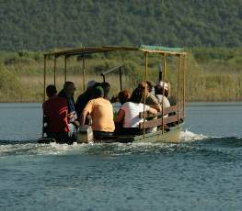
Boat in the Neretva Delta (photo Neretva & Trebisnjica project)

Wastewater Treatment and Marine Protected Areas: Mljet Island

This site visit gives exciting opportunities to discuss good practices in two different fields: wastewater treatment and marine protected areas. It will also be the only technical site visit during the IWC6 entirely within Croatia. Mljet is the most southerly and easterly of large Adriatic islands of the Dalmatia region of Croatia. The site visit will include stops at sites associated with two GEF IW projects. The first will be to the Mljet Wastewater Treatment facility (under the Croatia Coastal Cities project), followed by a visit to the island’s National Park, which is associated with the surrounding Marine Protected Area.
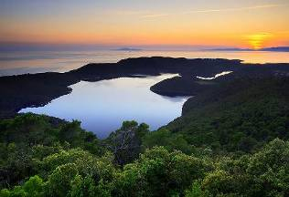
Lake within a lake at Mljet Island (photo Wikimedia)

Please note a few important dates
Registration Opens 1 July 2011
Start of visa application window for Croatia, BiH and Montenegro 17 July 2011
Finalization of Visa Arrangements 1 Sept. 2011
Closure of Registration 15 Sept. 2011
Targeted Workshops for GEF IW Project Managers & GEF Agencies 15-16 October
6th GEF Biennial International Waters Conference 17-20 October
Technical Site Visits to GEF IW Projects 18 October
Corporate and Social Responsibility Roundtable 19 October
Reception: Celebrating 20 Years of GEF Transboundary Water Results 19 October

Please note the following essential logistical information

Visas
Many people will need to acquire a visa for Croatia in order to attend the IWC. In addition, for people participating in the technical site visits to either Bosnia & Herzegovina or Montenegro, you will need a visa for either of those countries, as well as a multiple-entry visa for Croatia. Note that as of June 2011, holders of the UN Laissez Passer do not require a visa to enter Croatia or Montenegro. However, they do require one for Bosnia & Herzegovina. Please visit the following relevant web sites to acquire information on whether you need visas to enter Croatia, Bosnia and Herzegovina, and/or Montenegro:
Croatia Ministry of Foreign Affairs: http://www.mfa.hr/MVP.asp?pcpid=1615
Bosnia & Herzegovina Ministry of Foreign Affairs: http://www.mfa.ba/konzularne_informacije/vize/
Montenegro Ministry of Foreign Affairs: http://www.mip.gov.me/en/index.php/Visas-for-Foreign-Citizens/.

Transportation
The IWC6 falls at the end of the summer flight schedule for Dubrovnik Airport, though connections to many hubs in Europe are still available (Frankfurt, Munich, Vienna, London, Dublin, Barcelona). The summer schedule is available here:
http://www.airport-dubrovnik.hr/images/stories/red_letenja_za_2011.pdf
Note that the official conference airline is Croatia Airlines. Together with the Star Alliance Group of Airlines there will be reduced rates on flights operated by them to participants. The booking code will be disseminated to participants and published on the website in mid-July.

Venues & Accommodation
The IWC6 will be hosted from 17-20 October at the Valamar Lacroma Dubrovnik Hotel (do not confuse with the neighboring Valamar President Hotel). The street address of this hotel is Iva Dulčića 34 or GPS 42°39'36.87"N (42.660241666666664 N). The hotel reception can be reached at: +385 20 449 100. The managers workshops prior to the Conference will be conducted at the Villa Elisa.
The official hotel is also the Valamar Lacroma Dubrovnik Hotel: http://www.valamar.com/best-hotels-in-dubrovnik (as above). A block booking has been secured there, with single occupancy rates at 85 euros. The hotel is also offering lower rates at its neighboring property, the Tirena Hotel. Participants booking here, should book via the following link: http://www.mice-croatia-valamar.com/54939/6th-gef-biennial-international-waters-conference/

Language
The official language of the conference is English.

Currency
The official currency of Croatia is the Kuna, which trades at 100 HRK=US$19.1 or €13.4. In Bosnia & Herzegovina, the Convertible Mark is utilized, which trades at 100KM=US$74.8 or €51.1. Montenegro utilizes the Euro. Throughout the Dubrovnik town you will find ATM’s that can access your funds via the usual global networks (Cirrus, Maestro). You will also find money changers (called Menjacnica) in the old town and the hotel. Many places (restaurants and so forth) accept major credit cards, particularly in the old town, though it is advisable to carry some petty cash.

Weather
The weather along the Dubrovnik Region is a typical Mediterranean one, with mild, rainy winters and hot and dry summers. The air temperatures can slightly vary, depending on the area or region. The weather in autumn sees maximum temperatures typically between 20 °C and 23 °C and cooler nights.

Who organizes the IWC?
The GEF International Waters Learning Exchange and Resource Network (IW:LEARN) is responsible for organizing the IWC (www.iwlearn.net). The project is implemented jointly by the United Nations Development Programme (UNDP) and the United Nations Environment Programme (UNEP), with UNDP leading on supervision of the IWC. The Global Environment Facility itself also leads on the conference organization. The Conference would not be possible without critical support of the UNEP-hosted Mediterranean Action Plan for the Barcelona Convention, which executes the Mediterranean Regional project as well as critical support of the Croatian Government via the Ministry of Regional Development, Forestry and Water Management.
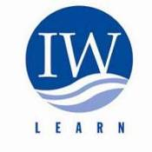
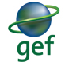
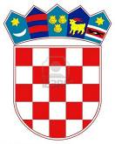
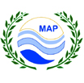
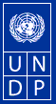

A Steering Committee exists to oversee the coordination and programming of the 6th Biennial GEF International Waters Conference and ensure its strategic role in the context of international waters management. Its membership includes all of the GEF Agencies.

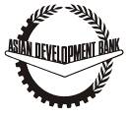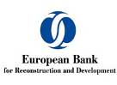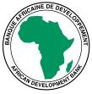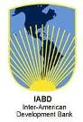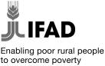

Who sponsors the IWC6?
Organizers are proud to acknowledge critical support from the following organizations with extreme gratitude:

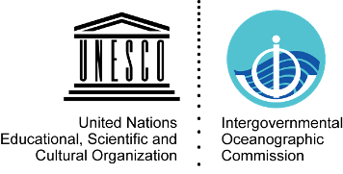
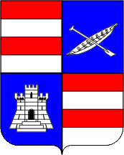
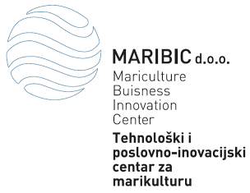

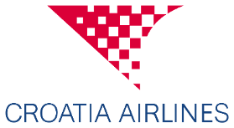
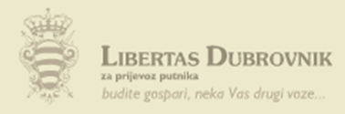



Call for Sponsors
The IWC6 provides a chance to engage a major cross-section of the actors engaged in managing an essential resource that has, in most cases, only international solutions. Working closely in partnership with multilateral, bilateral and private sector actors is vital to the success of GEF IW portfolio. The Organizers of the Conference appreciate any financial and/or in-kind support, including with the promotion of the Conference and its objectives.
This support may include:
- Assistance with conference logistics
- Assistance with the production of promotional materials
- Assistance with the organization social and cultural events
Through participation in the Conference you will be able demonstrating your achievements, products and materials, as well as share your views on the GEF development with other participants. Your logo will be used on Conference materials and you will have an opportunity to use the Conference logo on your products. Your contributions will be specially acknowledged by Conference Organizers and Officials.

For More Information: Contacts
You are invited to visit the Conference web site http://www.iwlearn.net/iwc2011 for up to date information on the IWC, including travel, visa and other administrative arrangements.
For all questions, please contact Conference Secretariat iwc6@iwlearn.org.
For more information on the five previous IWC’s, please visit http://www.iwlearn.net/iwc2009, /iwc2007, /iwc2005, /iwc2002 and /iwc2000.

